Payeer for CMS WordPress 5.5 (Woocommerce 4.4)
Log in to the admin panel and select “Plugins -> Add new”

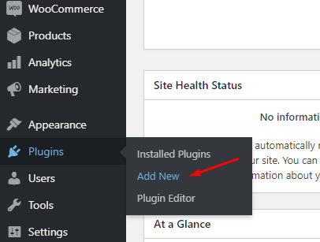
Press the button “Upload plugin”

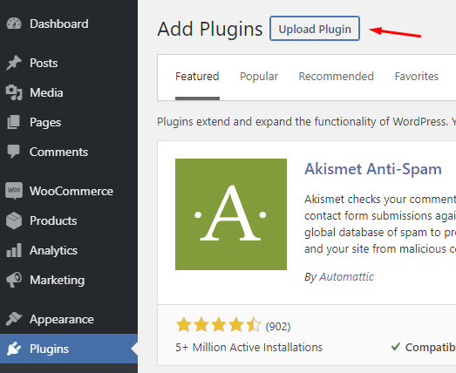
Click "Select file” and select archive in file explorer payeer_en.zip
Then click the button “Install Now”


Wait until the plugin is installed and you will see a notification about successful installation. On the installation confirmation page, click "Activate Plugin". Wait for activation.

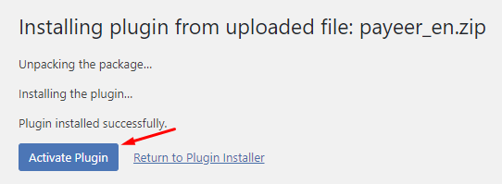

Then go to settings “WooCommerce”:

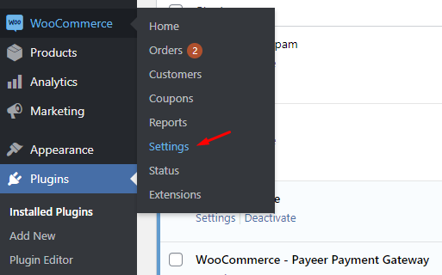

Select the "Payments" tab and open Payeer in the list of payment systems.

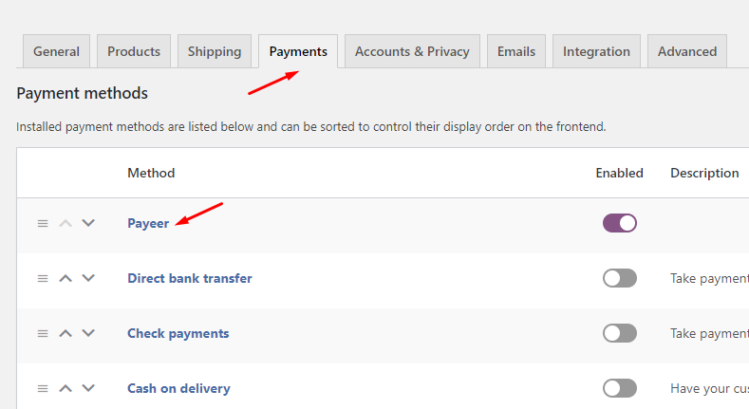

Fill in all the necessary fields, specify the name (Payeer), and check the enabled box to make the system available on the site.
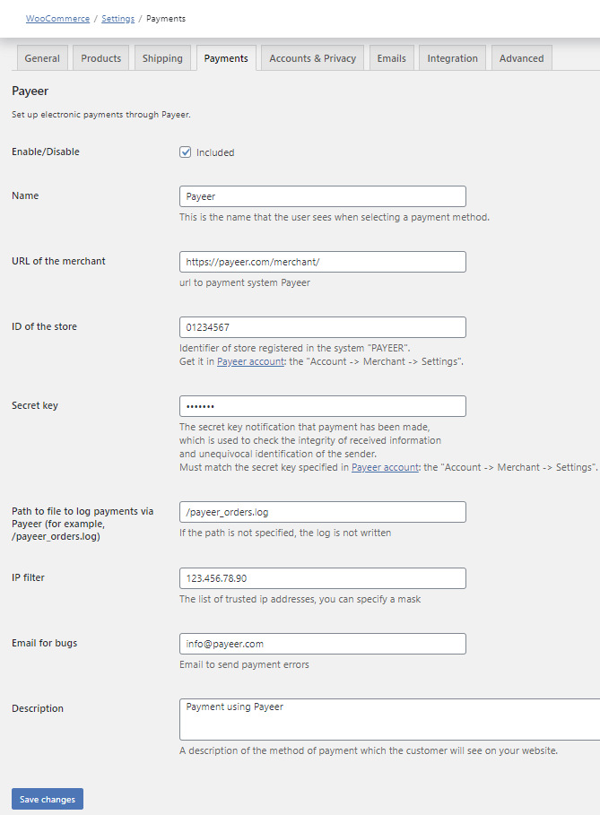
Merchant URL — the default way to pay //payeer.com/merchant/ (change only if an information notice from payeer.com about the change in payment URL)
Merchant ID — id of your store in the system payeer.com (you can learn in a private office)
Secret key – the secret key of your store in the system payeer.com (you specify it yourself)
Payment description — additional comment if you pay in Payeer
Path to logfile — specify the path to the file where to write the information on all payments via Payeer (if field is empty, the entry is not happening)
You can specify a list of trusted IP addresses of servers separated by commas. You can also specify a mask instead of an IP address. If the field is left empty, then checking for trusted IP addresses is not performed.

For example:
192.168.71.87, 192.165.83.17, 192.178.34.15
Or 192.*.71.87, 192.165.83.*, 192.*.34.15
Or *.*.*.* - available to all IP addresses

Enter your email address to receive notices in the event of a payment error. The letter will state the reason and basic information about the payment.
Enter the URL address in the “account Payeer → API → Merchant settings”
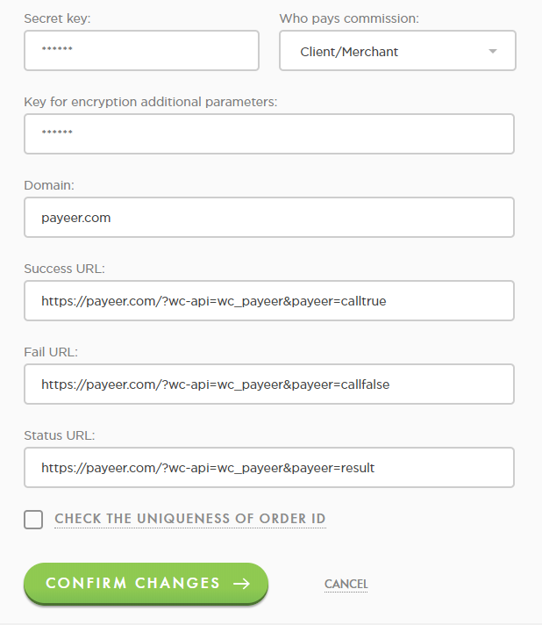

Success URL:
https://*****/?wc-api=wc_payeer&payeer=calltrue
Fail URL:
https://*****/?wcapi=wc_payeer&payeer=callfalse
Status URL:
https://*****/?wc-api=wc_payeer&payeer=result
Where ***** is your domain.
Module Payeer for CMS WordPress 5.5 (WooСommerce 4.4) is configured.

